Selenium Installation and Setup Handbook
Step 1: Install Java JDK and set environment variables
- Go to Oracle official site: https://www.oracle.com/java/technologies/downloads/
- Choose JDK 21 and download the installer for your OS
Ex: for Windows, refer below screenshot
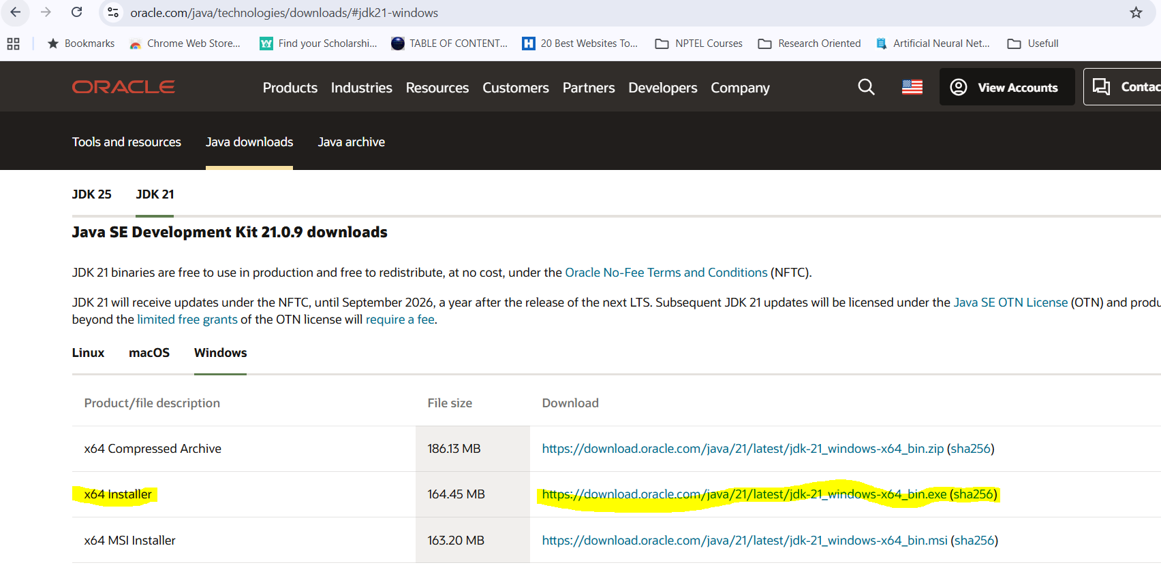
- Run the installer and follow prompts.
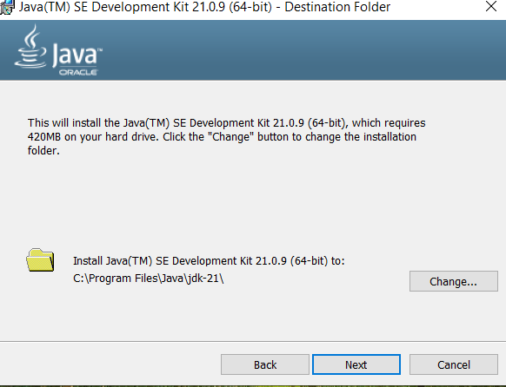
Note: If the installer asks to set JAVA_HOME/add to PATH, choose yes if available. If not, finish install and set manually (steps below).
- Use the full path to the JDK installation directory (the folder that contains bin, lib).
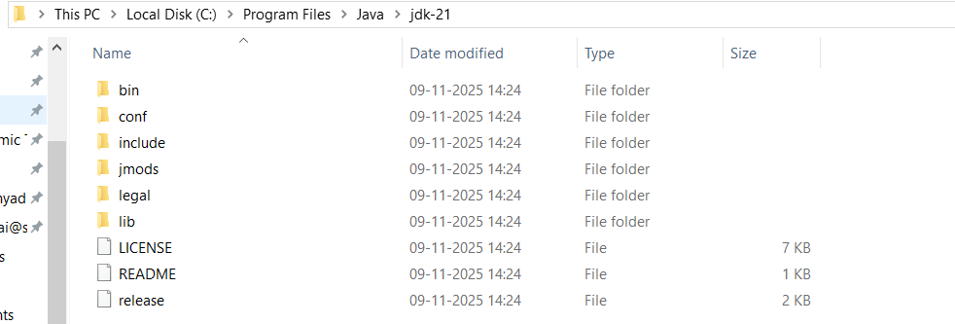
- Right-click This PC → Properties → Advanced system settings → Environment Variables.
- Under System variables:
  - Click New → Name: JAVA_HOME → Value: C:\Program Files\Java\jdk-21 (your actual path).
  - Find Path → Edit → New → %JAVA_HOME%\bin
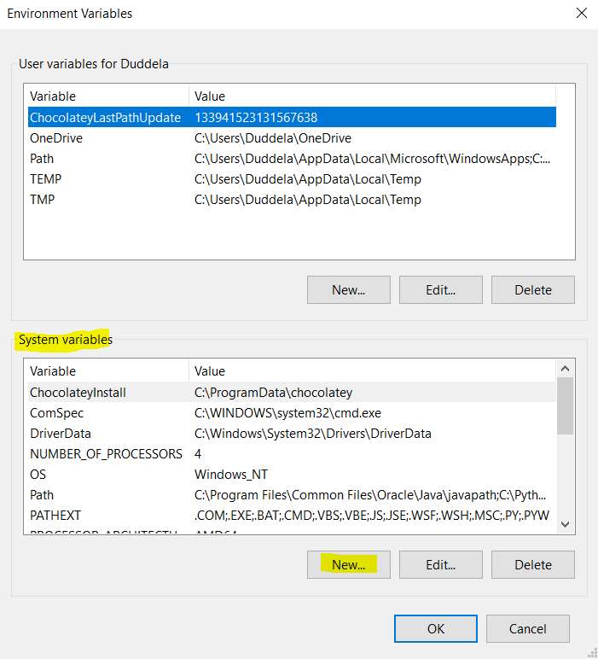
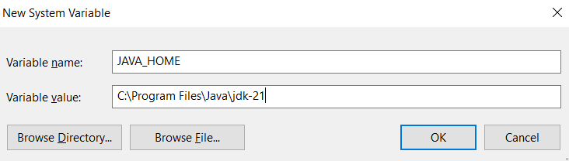
- Click Ok. It will be added.
- In the same Environment Variables window, scroll down in the System variables section, select the variable Path and Click Edit

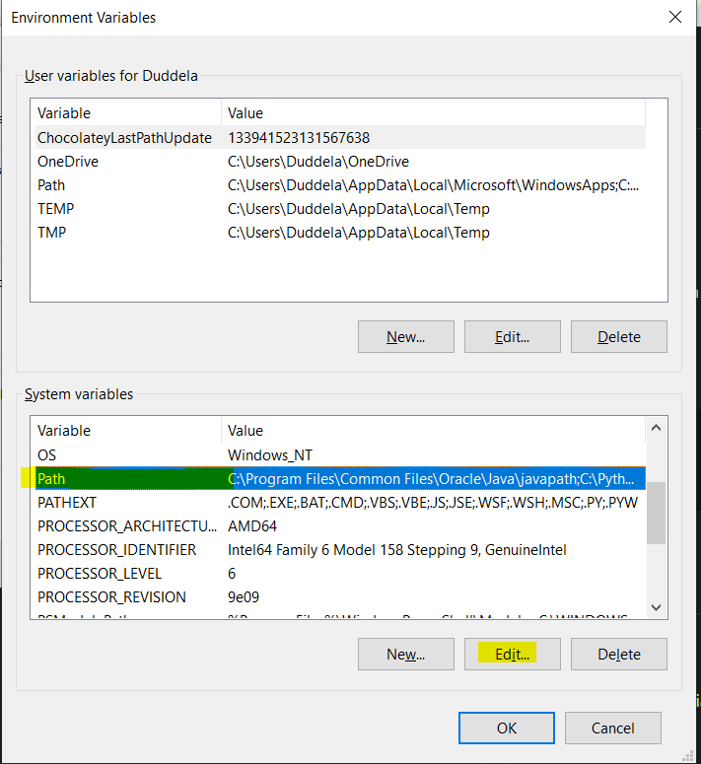
- Then, click New and add this line: %JAVA_HOME%\bin
- Click OK → OK → OK on all windows to close.
✅ This tells Windows to look inside your JDK’s bin folder for Java commands.
- Now, verify your configuration by opening a new Command Prompt (important! old ones won’t pick up new variables) and run below commands one by one.
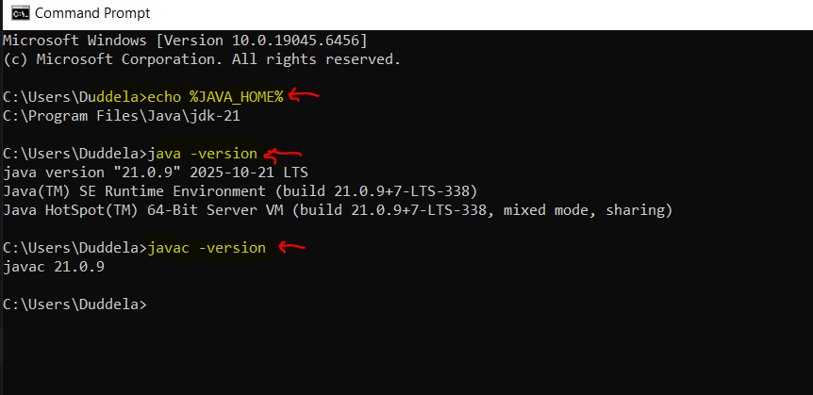
Java is fully configured
Step 2: Install and configure Maven
- Download Maven ZIP: 👉 https://maven.apache.org/download.cgi
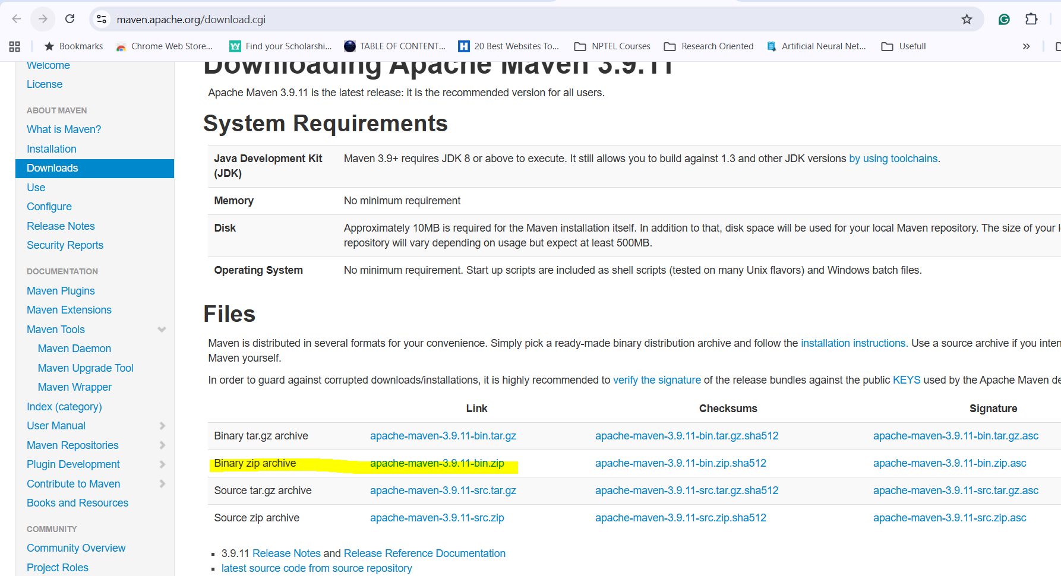
- Extract it to a location, e.g.: C:\Program Files\Apache\maven
- Set Environment variables. In System Variables, add a new variable:
  - Variable name: MAVEN_HOME
  - Variable value: C:\Program Files\Apache\maven
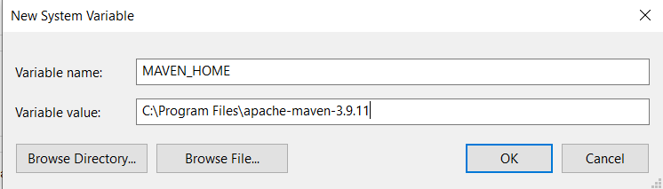
- Add this to the Path variable: %MAVEN_HOME%\bin
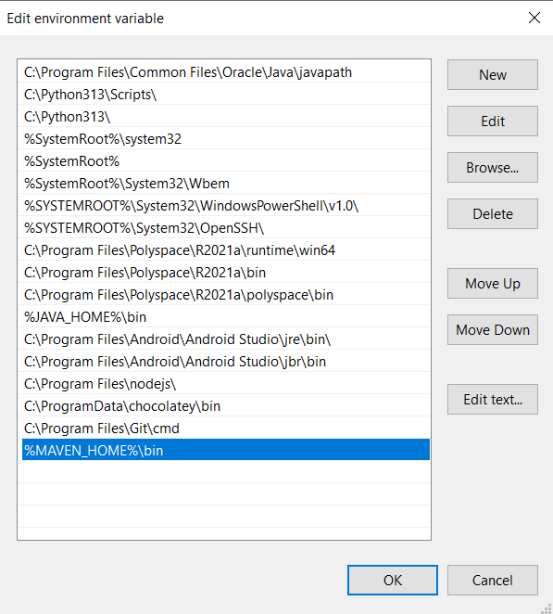
- Click OK → OK → OK
- Open a new Command Prompt and verify: “mvn -v”

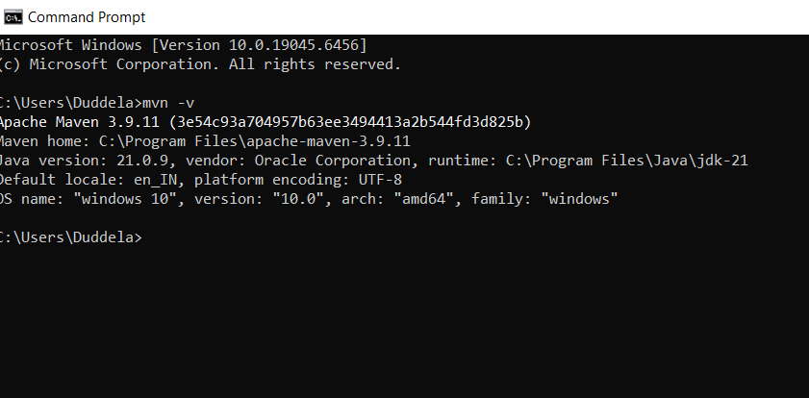
If you see maven version and java version, maven is installed successfully!
Step 3: Install Eclipse IDE for Java and point to JDK
- Go to 👉 https://www.eclipse.org/downloads/ and download
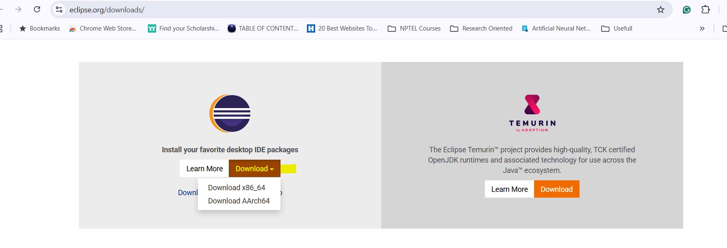
- Install and open it – Then, Choose Eclipse IDE for Java Developers
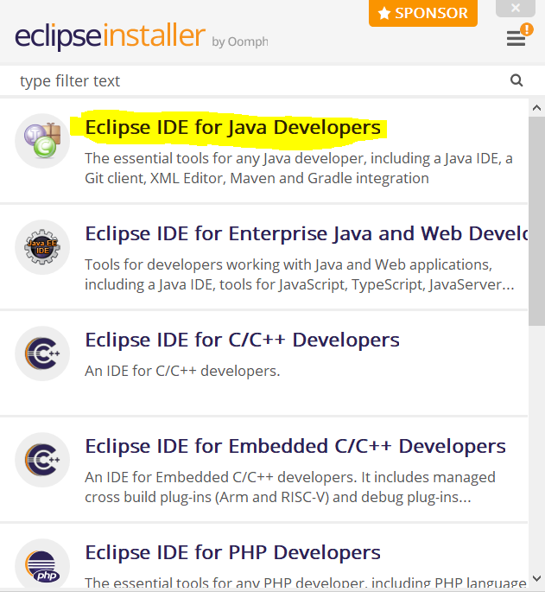
- Select the default location, click install and then launch.
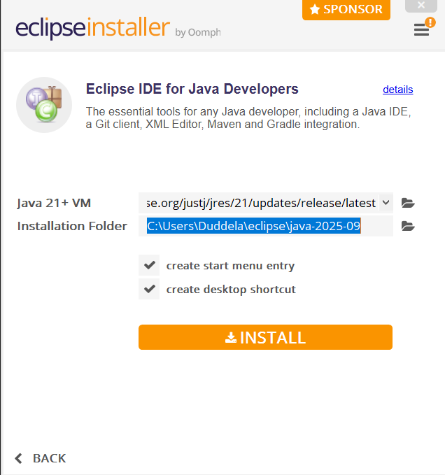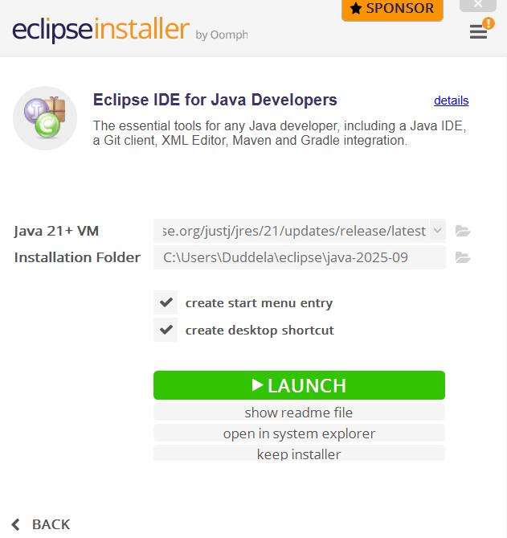

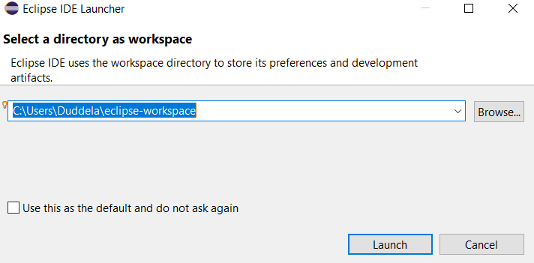
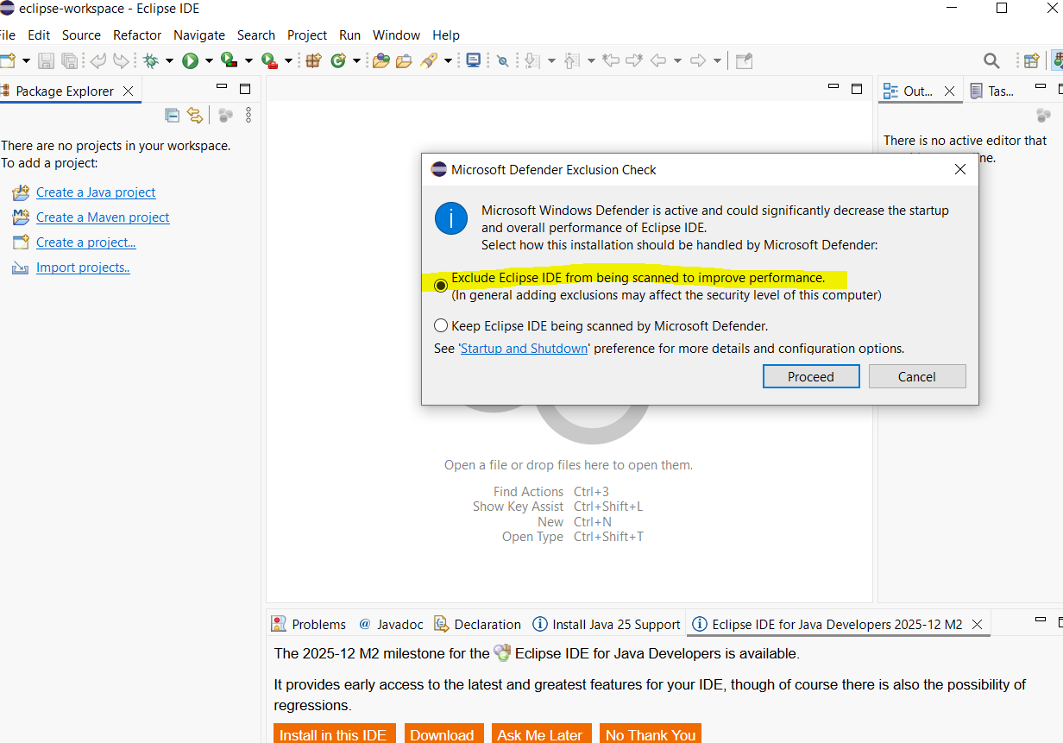
- Verify JDK integration
Once Eclipse opens:
  - Go to Window → Preferences
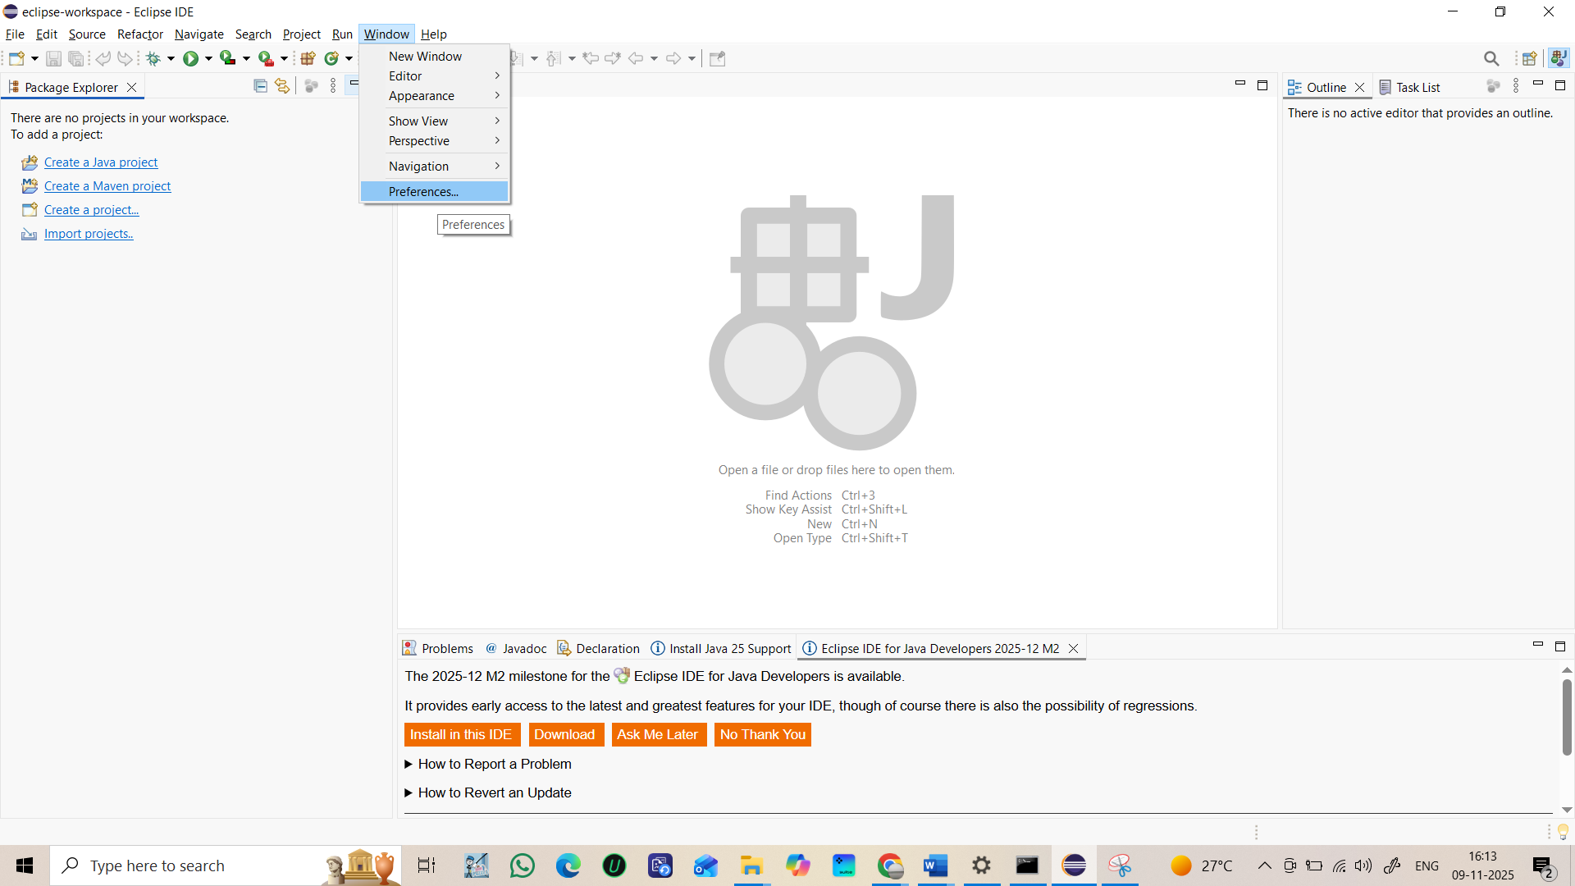
  - Expand Java → Installed JREs
  - Make sure you see:
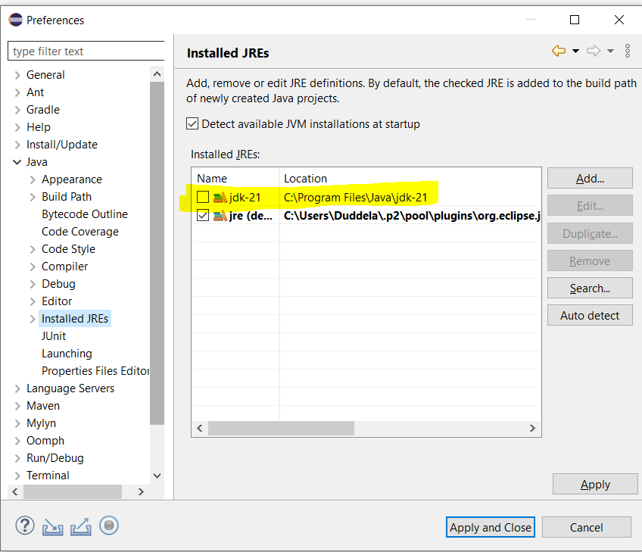
  - If not:
    - Click Add → Standard VM
    - Click Directory
    - Select your JDK folder (C:\Program Files\Java\jdk-21)
    - Click Finish → Apply and Close
Now Eclipse knows where your JDK is!
- Verify Maven integration
Eclipse for Java Developers already includes Maven by default. You can confirm:
  - Click Help → About Eclipse IDE
  - Click Installation Details → Installed Software
  - You should see “Maven Integration for Eclipse (m2e)”
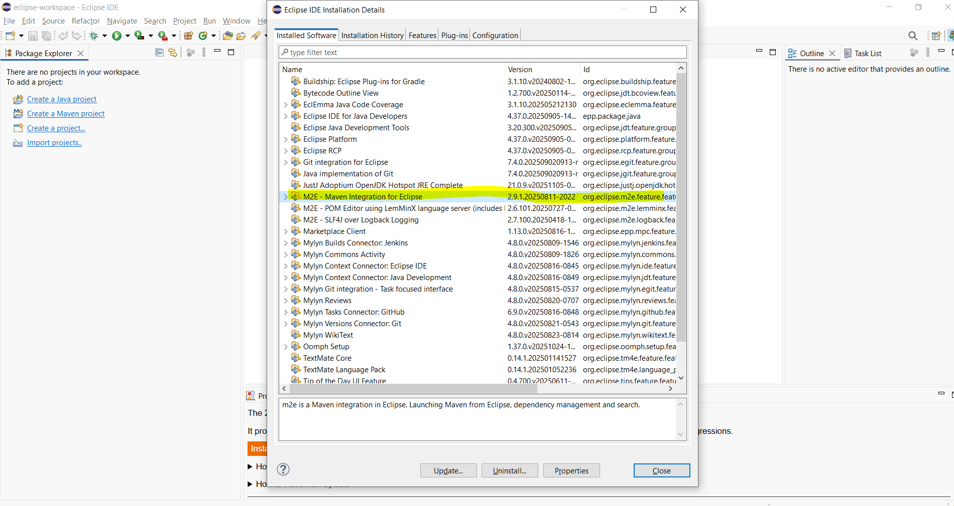
Step 4: Download ChromeDriver
- Selenium cannot open chrome browser, unless ChromeDriver is installed.
- Check your chrome version (Chrome://settings/help)
- Download matching ChromeDriver
- Extract and place it in C and add path in code.
Ex. For chrome browser of version 141.0.7390.123 👉https://edgedl.me.gvt1.com/edgedl/chrome/chrome-for-testing/141.0.7390.123/win64/chromedriver-win64.zip
After extracting, the single file should look like below
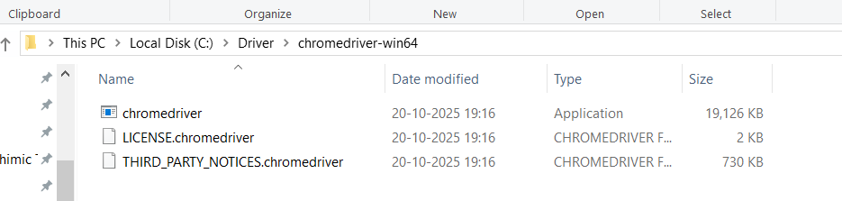
Step 5: Download Selenium Java JARs
- Download link : https://www.selenium.dev/downloads/
- Click below link to download latest Selenium java zip.
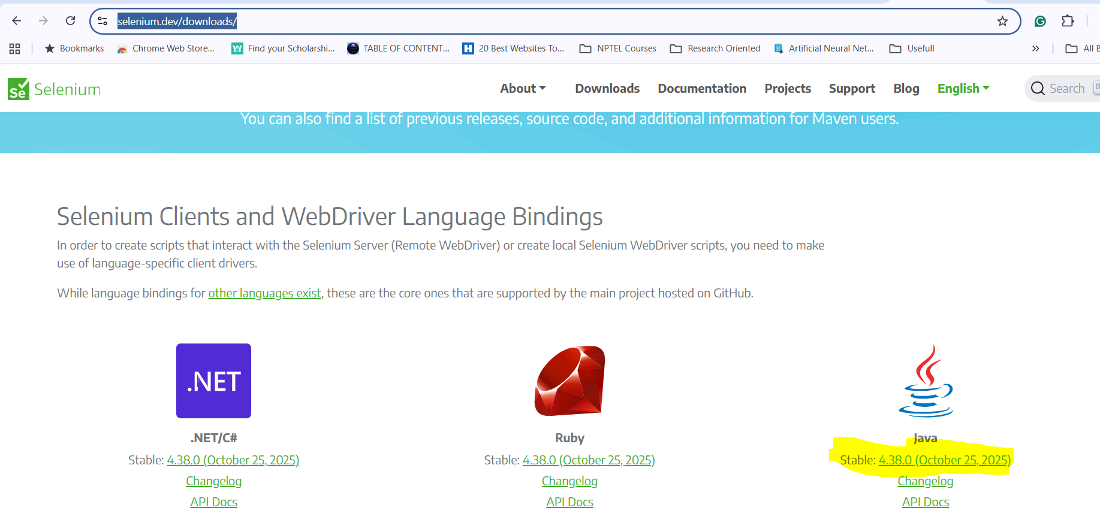
- Extract the ZIP to C drive.
- Create a Java Project. File → New → Java Project → Name: SeleniumDemo-Non-POM
- Go to configure build path.
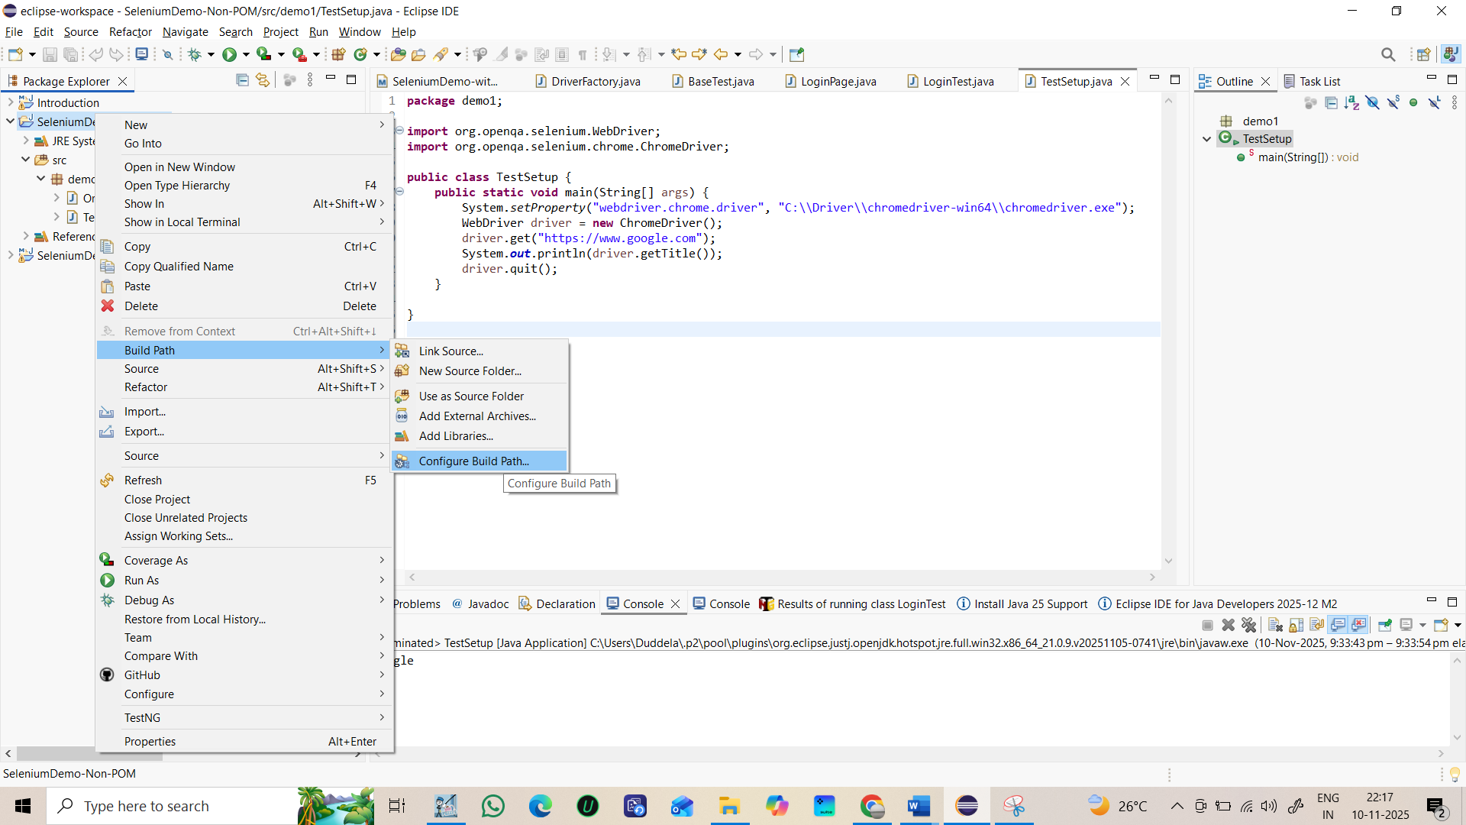
- Under Libraries select classpath click Add external JARs select the location of above extracted ZIP file click apply and close.
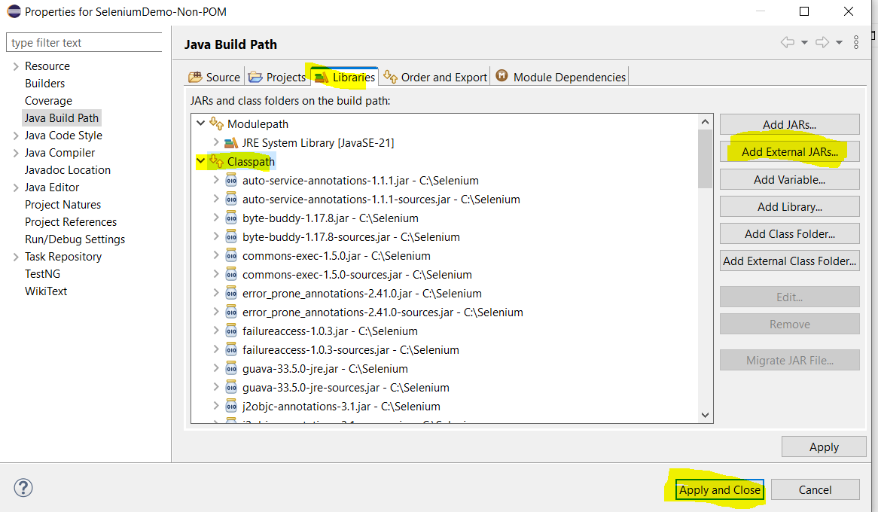
Step 6: Verify Setup
- Create a package under the above java project and name it demo1. Then create a class in the package and name it TestSetup.
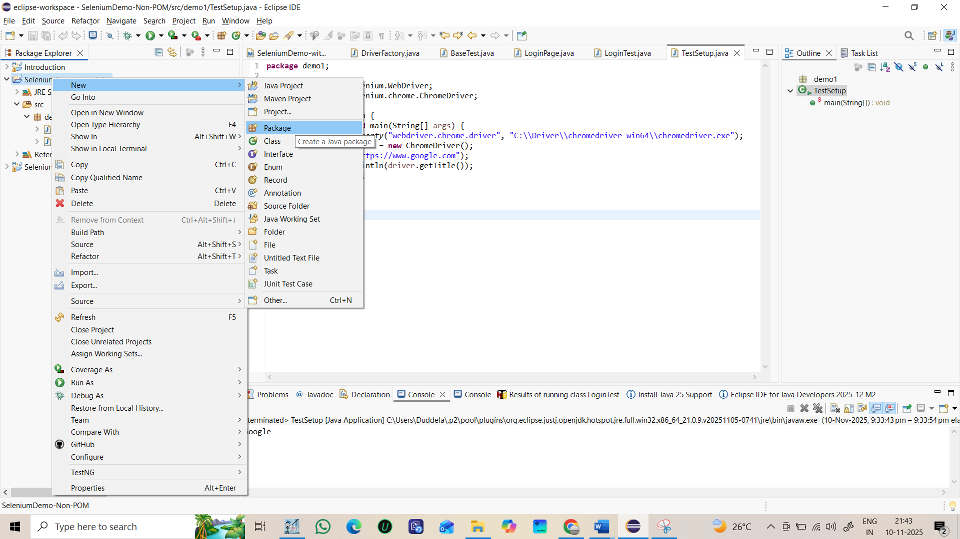
- Paste the below code and run as java application.
package demo1;

import org.openqa.selenium.WebDriver;
import org.openqa.selenium.chrome.ChromeDriver;

public class TestSetup {
public static void main(String[] args) {
System.setProperty("webdriver.chrome.driver", "C:\\Driver\\chromedriver-win64\\chromedriver.exe");
WebDriver driver = new ChromeDriver();
driver.get("https://www.google.com");
System.out.println(driver.getTitle());
driver.quit();
}

}

- Right click the class and run as java application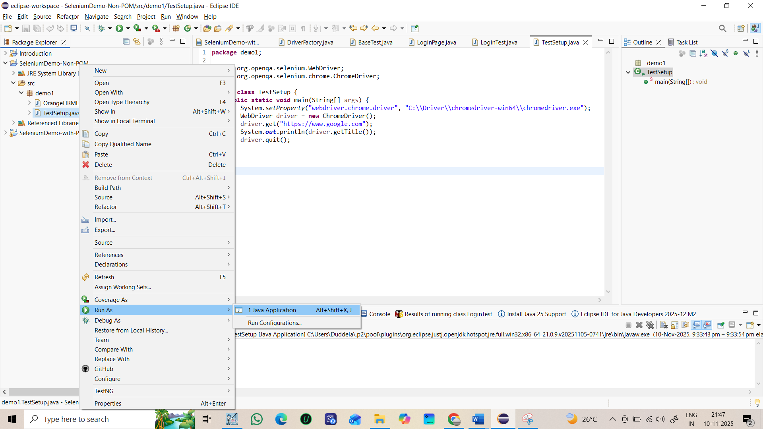
- Expected output is, chrome will be launched and google browser opens and google page title is printed in console.

